Term 3 – Week 6 – 30th August 2019 Absentee line ph 547 7582 or Text only 027 547 7582

PRINCIPAL AWARD: Ava Harley for an all-round excellent attitude, displaying all our school values at all times. Ava is a great role model to others. Keep it up – we are all very proud of you.  SUMMIT FRESH FRUIT AWARD: Sponsored by Chris Ferguson – Summit Stoke: This week we presented the fruit basket to Tryton R3 for superb writing (Maori land was his story). Tryton has displayed a great deal of self-determination in writing this story. Well done.  CLASS CERTIFICATES:  Ranui: Henry Douglas for safety; Welcome to Evey Patchett.  Room 1: Ella H-D for responsibility; Ella Harley for leadership in learning.  Room 2: Paige - responsibility for her learning in all classroom areas;  Levi - displaying a positive work ethic in the classroom  Room 3: Tryton for Rangatiratanga and leadership in Te Reo and Waiata; For Zeva the huge effort she is making in Rangatiratanga  Room 4: Dylan Thompson for progress in Reading. Zoe for Tino Rangitiratanga in all things but especially her bike riding.  Room 5: J.T. for responsibility; Serenity for reading.  Room 8: Jessie-Lee was away last week so we are presenting her award this week and Aiza-Lyna, for Rangatiratanga in learning.  Room 9: Annabelle for great communicating; Mathew for responsibility  Room 10: Aryana Spell for being a wonderful bucket filler to her classmates AND her teacher. Tom Allan-Kereopa for his excellent understanding of how to use capital letters correctly every day.  Room 11: Liam Waugh Tino Rangtiratanga; Charlie Allan-Kereopa for giving his best effort to all of his work.  SCHOOL CHECK IN: It has been a busy week again. Never a dull moment – all classes are working hard, and I have been enjoying visiting them all over the week. Currently, class teachers are undertaking observation for their appraisals.  The school were invited to the senior Stoke School speech competition. It was very interesting to hear the range of speeches. Our selected finalists to represent us are: Rosie Goomes and Katie Gray. Rosie came first here at school, her topic Heritage. Katie Gray came second talking about vivisection. A joint third was awarded to Vanessa Bell and Ella Harley. Vanessa spoke about school and Ella about bullying. Well done to all other students chosen to deliver their speeches in the hall. A huge thanks to the audience who demonstrated respect to each speaker.  The Interschool Speech Competition is on Wednesday 4th @ Nayland Primary at 7pm. You are of course invited to attend and support our representatives – Rosie and Katie. All the best girls.  By now our Year 6’s will be considering, and most will have completed, their pre-enrolment for 2020. If you have not done so, please do. If you have any concerns about your child transitioning to Intermediate, please see the class teachers and they can assist you.  Also, for those of you who might like to purchase a ticket, we have a raffle fundraiser running at the office for Year 6 camp. They are off to camp on December 2nd and are busy raising money to support all year 6 students to attend.  Last week we sent home a survey for our Māori whānau to complete. I have had a few returned and encourage those who identify as part of our Māori community to do so. If anyone would like to see a copy of the survey, please ask at the office.  You will have noticed that David spent a good part of the day this week water blasting out the front of the school. We are very appreciative of his time and it was certainly a mucky job, but it looks fabulous. Thank you very much David! This is another great step towards completing our waharoa. I am in the process of collecting quotes for the plastering/rendering and so if anyone knows of a local company that is good value for money please let us know.  A few notices in relation to managing our tamariki and helping them manage themselves too;  It is very concerning that a number of children are crossing the carpark unsupervised. As much as we put out the message about using the footpath, it is our smallest children, those least visible and more likely to be hidden in your blind spot, who take this risk. Please remind your children to use the footpath.  There has been a huge reduction in people driving through the barrier arm area and on to the grass. This is much safer for our tamariki and we thank you for not crossing that footpath running behind the old dental clinic – from the pedestrian crossing to the hall.  Lost property is accumulating much more slowly, so well done for naming items. It was unfortunate that someone added a number of very wet items from the playground which created a bit of a mess, but thanks to Mel for taking this home to wash and clean.  Sports uniforms – these are funded by the PTA for sports teams. It is important that they are returned at the end of sporting seasons for repair and replacement. If you have one at home which you no longer require for sports, please return to the box at the office. Much appreciation in advance for their return,  Lunches – We have a few seniors who seem to have had a growth spurt lately and their home lunch is not enough. Please do not be offended if we offer them fruit, a sandwich or muesli bar. Hangry (hungry + angry = hangry) children are not ready for learning, or a whole pile of fun. If you prefer this not to happen let us know, but please do have a chat with your child about their lunch. Another thing we have noticed is that some children do not like the contents of their lunch box – we have asked them to let you know as a parent.  On Mondays we have Elim church support group provide chicken noddle soup and a fresh bread roll. We encourage the children to bring a re-useable cup for this which they can either wash out at school or take home til the next week. In this era of very climate change conscious students this may appeal to some over the one-use cups provided. I know the soup is popular on the cooler days. A huge thanks to the Elim church group for providing this for our tamariki – perhaps your child might like to make a card for them if they are enjoying the soup.  Finally, this week, we have done some maintenance on the playground. It is aging equipment. If you notice anything that needs attention, please let us know. If we are able to keep it in good condition it will last longer. Again, if there are any people out there with a little time a coat of stain will preserve the integrity of the wood for a little longer. We have brushes, stain and trays for any keen hands. Maybe a small group of families might like to take this on?  Have a great weekend. It certainly is warming up and the daffodils are poking their heads out everywhere. See you next week. | KIDZ CORNER:  The year 5/6 classes have been exploring scientific investigations. They have had fun with elephant toothpaste - Elephant's toothpaste is a foamy substance caused by the rapid decomposition of hydrogen peroxide using potassium iodide as a catalyst. How rapidly the reaction proceeds will depend on the concentration of hydrogen peroxide. You can ask our scientists about this reaction (photo bottom right). Our scientists have also looked at oil and water – they discovered oil is less dense than water, it will always float on top of water, creating a surface layer of oil. Some great scientific observations occurred.  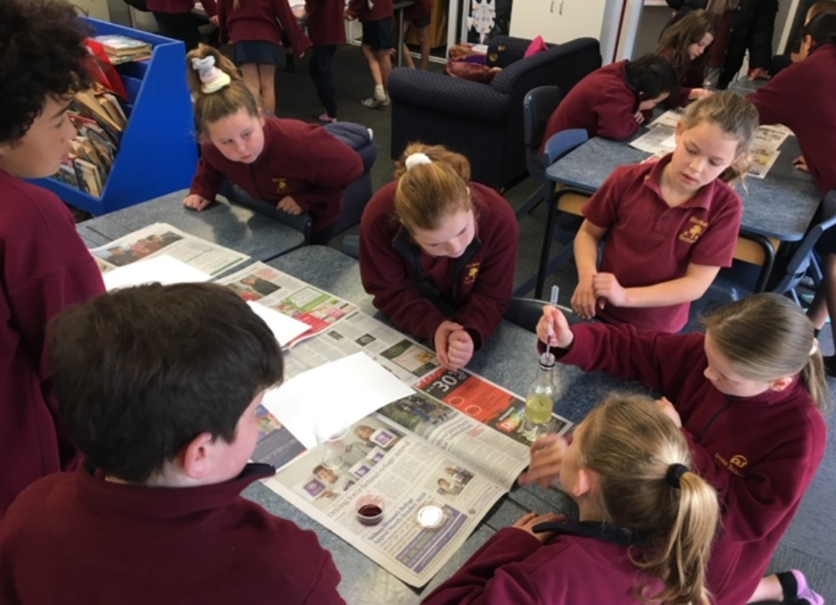  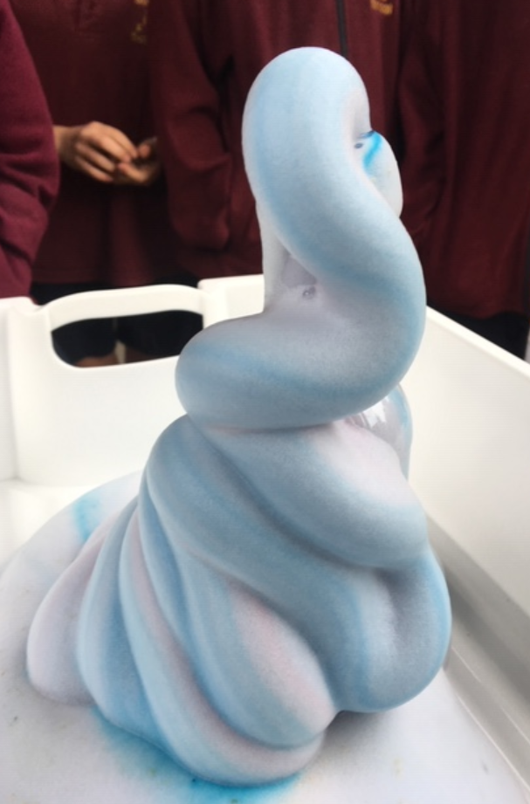  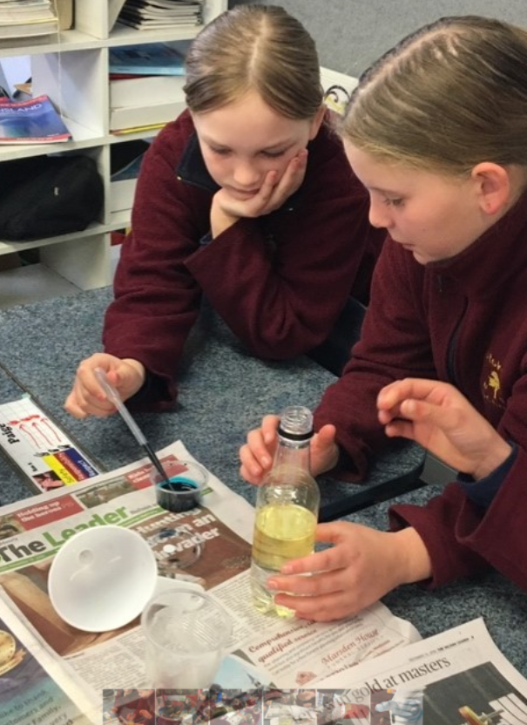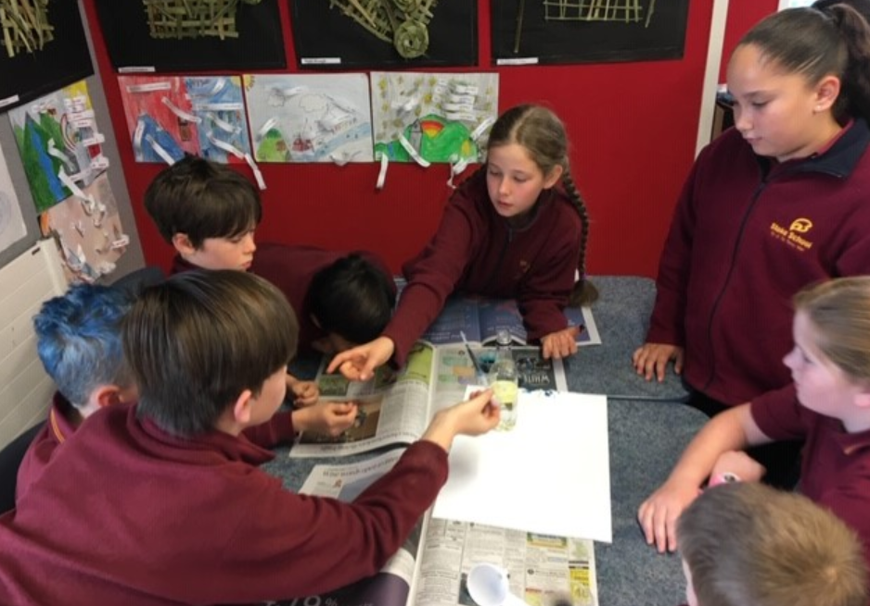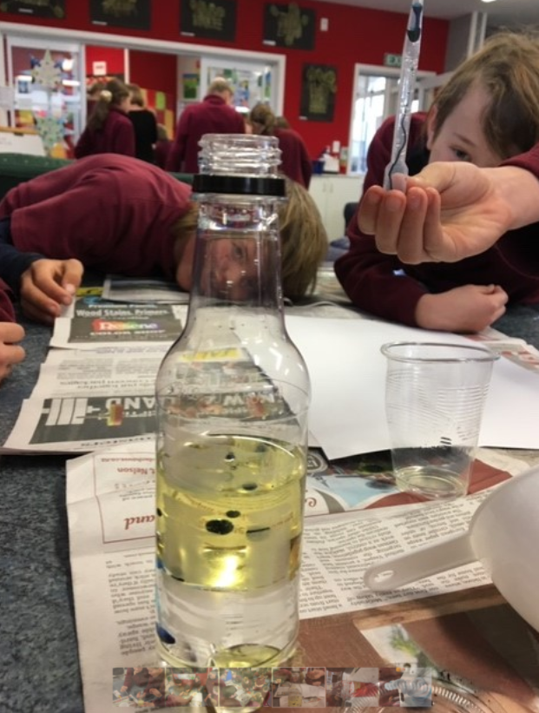  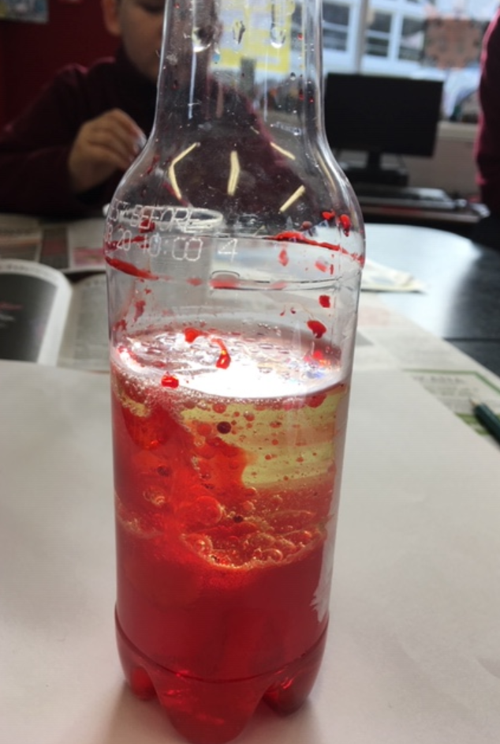  NIKE SHOE SWAP: A couple of our students decided on swapping shoes, unfortunately for one he gained a size 13 children’s size. His shoes are a size 2 youth. If your child has come home in the later pair of an all black nike shoe, can you please return these to the school office and we will make a swap. 😊  ROCK DA HOUSE – TICKETS ON SALE NOW AT SCHOOL OFFICE:  Stoke School will be performing with over 400 other students on the evening of Tuesday 17th September. This is a fantastic entertaining evening held at Trafalgar Centre at 7.30pm. Doors open for pre entertainment at 7pm. Seat tickets are $15.00 each and are available at the school office. Gather your family and friends for an evening of music.  SUBWAY Richmond is now refurbished and Friday Subways continue.  SHARE YOUR THOUGHTS:  This year our school has been part of a professional development programme which focuses on Teachers and the role they play in building relationships for learning and creating a learning culture in the school. This professional development programme is a focus for our Kāhui Ako (Community of Learning)  Each year we interview staff, students and whānau to give our school feedback. Our voice collection date is coming up soon and we would love for you to be part of the interviewing team.  This will mean that we would love for you to meet in our office on Wednesday the 11th of September at 1pm. During this time you will be with a group of parents and a trained teacher from our Kāhui Ako (Community of Learning) there are 3 simple questions you will be asked about what helps your child to learn and what they enjoy most about learning.  If you would like to be a part of this discussion please email saraho@stoke.school.nz by Friday the 6th of September.  POWERZONE HOLIDAY PROGRAMME: Monday 30th September to Friday 11th October. Get a brochure from the school office  POWERZONE AFTER SCHOOL CARE is two minutes' walk from the school at the Elim Christian Centre and pick up is free. We provide a safe, fun programme, healthy afternoon tea, supervised homework and a variety of weekly activities. OSCAR and CYF approved. WINZ subsidy available. For more information contact 547 2544 or nelson@elim.org.nz  INTERNET PAYMENTS: Please feel free to pay any payments for fees, trips etc direct to the school bank account number: Stoke School BOT 031709-0021954-00 Reference detail: Childs name and what you are paying for. Any questions see Megan.  CLASS ASSEMBLY: Todays assembly was a whole school assembly with room 8. Next week's assemblies are syndicate assemblies. Syndicate assemblies are seniors at 12pm in the hall (Woodstock centre) and juniors at 2:30pm in Ranui.  BOT MEETING: Next BOT meeting is the 16th September held at 7pm at the school staff room. All Welcome.  Sarah Davies  PRINCIPAL

